Project Planning Phase
Project Planning Template (Product Backlog, Sprint Planning, Stories, Story Points)

Date | 08 October 2026
Team ID | 9100Byte
Project Name | Implement Client Script & UI Policy (Incident)
Maximum Marks | 5 Marks

Product Backlog, Sprint Schedule, and Estimation (4 Marks)
Use the below template to create product backlog and sprint schedule for the Incident Client Script and UI Policy project.
Sprint | Functional Requirement (Epic) | User Story Number | User Story / Task | Story Points | Priority | Team Members
Sprint-1 | Incident UI Policy | USN-1 | As a ServiceNow administrator, I can create a High Impact Control UI Policy for the Incident table when Impact is High. | 3 | High | B Abitha  A G Rashmeka
Sprint-1 |  | USN-2 | As a support user, I can make Assignment group mandatory for High Impact incidents and restore normal behavior when the condition is false. | 3 | High | B Abitha  A G Rashmeka
Sprint-1 |  | USN-3 | As a support user, I can view Urgency as read-only while the Incident Impact is High. | 3 | High | B Abitha  A G Rashmeka
Sprint-1 |  | USN-4 | As a support user, I can have Urgency automatically set to High when the Incident Impact changes to High. | 3 | High | B Abitha  A G Rashmeka
Sprint-2 | Incident Validation & List Control | USN-5 | As a support user, I cannot submit a High Impact Incident when Assigned To is empty. | 3 | High | B Abitha  A G Rashmeka
Sprint-2 |  | USN-6 | As a support user, I cannot change Incident State directly through list editing. | 3 | High | B Abitha  A G Rashmeka
Sprint-2 |  | USN-7 | As a support user, I can verify successful submission after the required Assigned To value is provided. | 3 | Medium | B Abitha  A G Rashmeka
Sprint-2 |  | USN-8 | As a support user, I can verify condition reversal and normal form-based State updates after the Incident conditions change. | 3 | Medium | B Abitha  A G Rashmeka

Project Tracker, Velocity & Burndown Chart: (4 Marks)
Sprint | Total Story Points | Duration | Sprint Start Date | Sprint End Date (Planned) | Story Points Completed (as on Planned End Date) | Sprint Release Date (Actual)
Sprint-1 | 12 | 5 Days | 08 Oct 2026 | 12 Oct 2026 | 12 | 12 Oct 2026
Sprint-2 | 12 | 5 Days | 13 Oct 2026 | 17 Oct 2026 | 12 | 17 Oct 2026

Velocity:
The project is planned for a 10-day duration across two 5-day sprints. The total planned velocity is calculated from the story points completed per sprint.
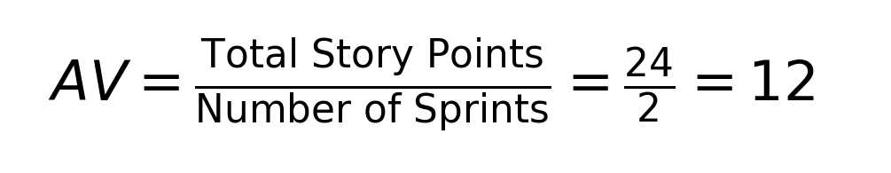

Burndown Chart:
The burndown chart represents the remaining work for the Incident Client Script and UI Policy implementation against the planned sprint timeline.

Source: Implement Client Script & UI Policy (Incident) project document.

Reference:
Project scope: ServiceNow Incident UI Policy and Client Scripts.
Team ID: 9100Byte
Project date: 08 October 2026
Implementation basis: supplied Incident project document

